**Andrei-Constantin Bolboceanu**

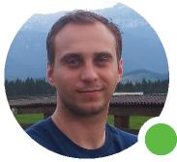



Frontend Developer @ Freelancing   
Brașov, 37 years, Male

**PROFESSIONAL EXPERIENCE**

**Freelancer** in Brașov, Romania

**Frontend Developer**

March, 2022 - Present

In 2022 I discovered my passion for coding and I've been learning it ever since. I am building different web based applications and understand the concepts behind them. I am passionate about new technologies and their future potential, enthusiastic, self-motivated and curious by nature. I am a great problem solver, have the capability to work independently as well as with a team, and have the willingness to learn from other programmers.

**JOYSONQUIN AUTOMOTIVE SYSTEMS ROMANIA** in Ghimbav, Romania

**Procurement specialist**

March, 2022 - Present 1 year

Delivering high-quality purchasing services on a day-to-day basis according to defined automotive procedures, respecting quantity, quality and timing.

**TotalEner****gies Marketing**  **ROMANIA** **(Cristian)** in Cristian, Romania

**Supply chain specialist**

May, 2017 - May, 2022

Oversee and ensure proper flow of the supply chain taken into consideration the process from ordering materials all the way until product deliverance.

**Intercars Romania**in Brașov, Romania

**Warehouse specialist**

March, 2013 - April, 2017

Oversees daily operations in the warehouse, including coordinating shipping schedules, tracking inventory and running team meetings. As a management position, additional duties includes supervising the warehouse workers, shipping and receiving clerks, and other staff.

**ROPHARMA SA BRASOV** **(Brașov)** in Iași, Romania

**Treasury Specialist**

May, 2008 - February, 2013

Working with company's liquidity with ability to turn investments into cash. Also monitoring the purchase and sale of investments, evaluating financial records, and making recommendations on ways the company can save money towards their financial goals.

**ABOUT ME**

I am self-motivated, autodidact person, motivated for success and a team player.

I am also a funny person and I easily empathies with everybody.

In 2022 I discovered my passion for coding and I've been learning it ever since. I am building different web based applications and

understanding the concepts behind them. I am passionate about new technologies and their future potential, enthusiastic, self-motivated

and curious by nature. I am a great problem solver, have the capability to work independently as well as with a team, and have the willingness to learn from other programmers and mentors.

**Education**

**Self Education**

March 2022 - present

**Online courses for Front-End development**

-**Udemy**: The Complete Front-End Web Development Course, *created by Joseph Delgadillo & Nick Germaine*;

-**Freecodecamp**: Learn how to code;

-**Teamtreehouse**: Front-End development course;

-**W3schools**: Learn to code;

-**Stackoverflow**;

-**MDN**;

-**"Eloquent JavaScript"** by Marijn Haverbeke;

-**"You don't know JS"** by Kyle Simpson;

**Management and business administration**, University (bachelor degree), Iasi

**Alexandru Ioan Cuza**

2008 - 2012

Studied Economics where I learned numerous topics which includes: accounting and management information systems, Math, Economics, etc.

**Colegiul National de Transporturi**, High school (graduate), Iasi

2001 - 2005

Studied intensive Math, Computer Science, Physics and Chemistry.

**Skills, tools & technology**

The wonderful world of Front-End coding requires many skills but at the moment I am still learning and below you can find what I know so far.

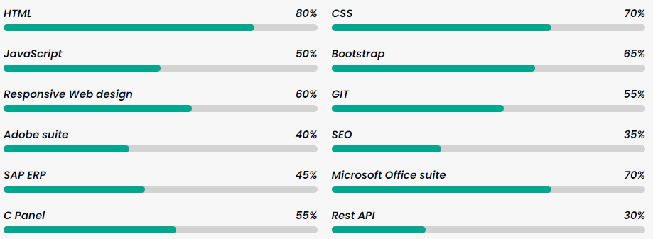

I've started learning and understanding **React**. This is work in progress.

**SPOKEN LANGUAGES**

Romanian native

English advanced

French medium

**Other**

I have a driving license